**16. How can you produce dynamic data for your testcases like id, firstname, company, phno?**

To generate dynamic and realistic data for test cases, we often utilize the `Faker` class, a valuable tool that provides mock data. This helps in testing scenarios where we need varying data like IDs, first names, last names, company names, and phone numbers. To integrate `Faker` into our project, we start by adding the necessary Maven dependency to our `pom.xml` file:

Dependency:

<dependency>

<groupId>com.github.javafaker</groupId>

<artifactId>javafaker</artifactId>

<version>1.0.2</version>

</dependency>

Next, we instantiate the `Faker` class in the respective testing class where we need dynamic data. With this instance, we can call appropriate methods

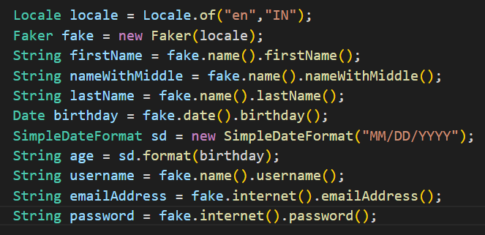

In this way, we incorporate `Faker` to produce varied and valid data for our test cases. It promotes testing flexibility by supplying realistic yet random data.

**Reference link:** [**Faker Doc**](https://www.youtube.com/watch?v=CIv5xCBLzyA&t=185s)